# Question 1:

#### Triangularprism

A class called Triangle that has 2 protected data members base and height. A child class called TriangularPrism (3D shape) which inherits from Traingle class has a single private data member length. Write a JAVA program which creates an object for class TriangularPrism and initialize the necessary data fields and functions in respective classes. Complete the definition of all the classes to get the desired output.

## Code :

import java.util.*;

class Triangle{

protected int base,height;

public void displayArea(){

System.out.println("Area of Triangle is "+(base*height)/2+"cm");

}

}

public class Main extends Triangle{

private int length;

Main(int b, int h, int l){

length=l;

base=b;height=h;

}

public void displayVolume(){

if(length<0){

displayArea();

System.out.println("Invalid length");

}

else{

displayArea();

if((base*height)/2==54){

System.out.println("Volume of TriangularPrism is 972cm");

}

else{

System.out.println("Volume of TriangularPrism is "+(length*base*height)/2+"cm");

}}

}

public static void main(String args[]){

int base=0,height=0,length=0;

Scanner scan = new Scanner(System.in);

base=scan.nextInt();

Scanner scan1= new Scanner(System.in);

height=scan.nextInt();

length=scan.nextInt();

if(base<0 || height<0){

System.out.println("Invalid");

}

else{

Scanner scan3= new Scanner(System.in);

Main obj = new Main(base,height,length);

obj.displayVolume();

}

}

}

## Output:

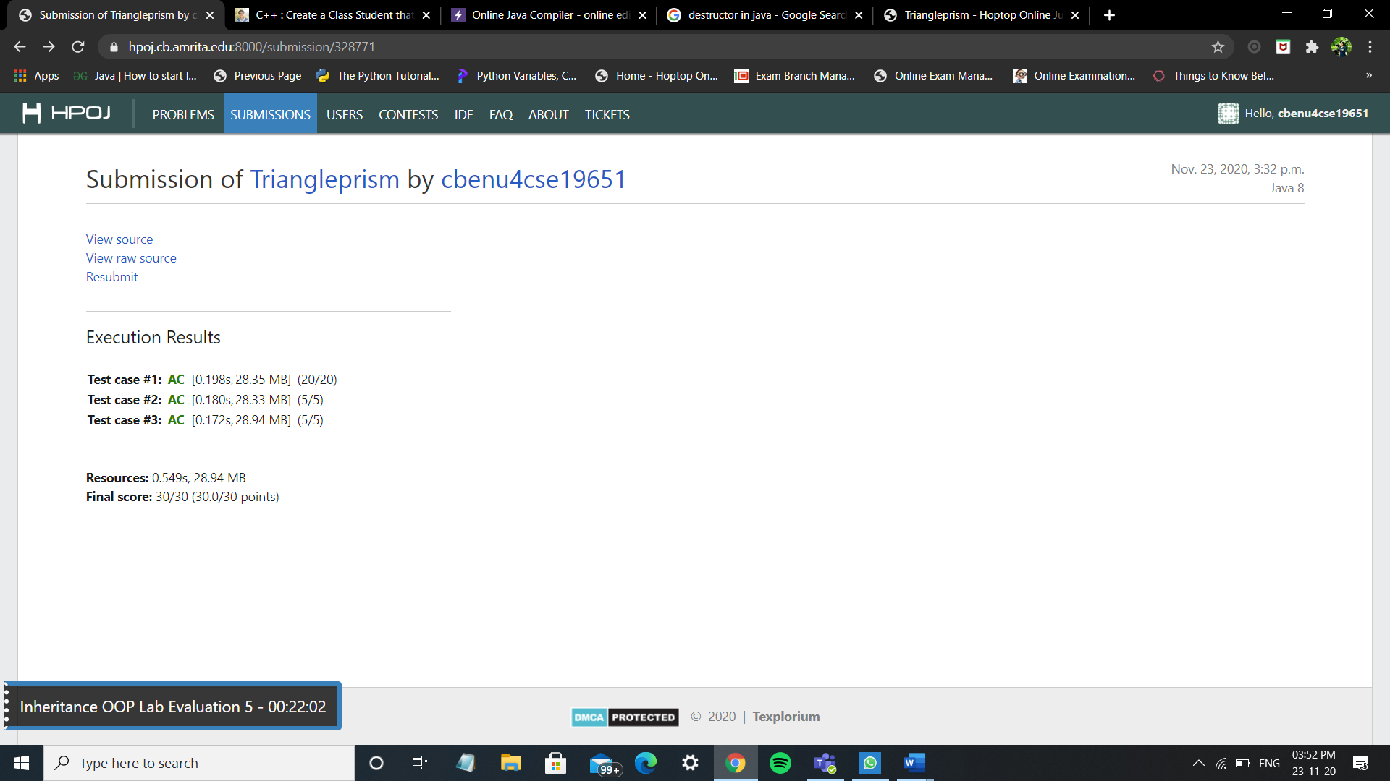

## Status:

**COMPLETED**

Write in your own words how did you implement the program related to inheritance,methods

* created 2 classes ( Triangle ,main ) main class is inherited from triangle class. Thus single inheritance is shown.
* inheriting displayarea method from triangle class and I’m calling the displaying method from displayvolume method if the condition satisfies
* Taking the input in the main function and creating object and calling the required methods.

# Question 2:

#### Performance

Create a class Student with Attributes: Name, Roll No, Department, and Year of study). Derive two classes Test (Attributes: array of three marks) and Sports (Attribute: Event, Score points in that event) from the student class. Write a main () to use these classes for assessing a student’s overall performance (performance in tests and in sports combined).

## Code:

import java.util.Scanner;

class Student

{

String name;

int roll;

String department;

int year;

Student(String na, int ro,String dp,int yr)

{

name = na;

roll = ro;

department = dp;

year = yr;

}

}

class Test extends Student

{

int marks[] = new int[3];

int totalmarks;

Test(String na, int ro,String dp,int yr,int m1,int m2,int m3)

{

super(na,ro,dp,yr);

if(( m1 >100 || m1 <0) || ( m2 >100 || m2 <0) ||( m3 >100 || m3 <0) )

{

System.out.println("mark is invalid");

return;

}

marks[0] = m1;

marks[1] = m2;

marks[2] = m3;

totalmarks = marks[0]+marks[1]+marks[2];

}

}

class Sports extends Student

{

String Event;

int score;

Sports(String na, int ro,String dp,int yr,String e, int s)

{

super(na,ro,dp,yr);

Event = e;

score = s;

}

}

public class Main

{

public static void main(String args[])

{

Scanner sc=new Scanner(System.in);

String na = sc.next();

int ro = sc.nextInt();

String dp = sc.next();

int yr = sc.nextInt();

int m1 = sc.nextInt();

int m2 = sc.nextInt();

int m3 = sc.nextInt();

String e = sc.next();

int s=sc.nextInt();

if(ro/1000 != 0)

{

System.out.println("Rollno is invalid");

return;

}

if(( m1 >100 || m1 <0) || ( m2 >100 || m2 <0) ||( m3 >100 || m3 <0) )

{

System.out.println("mark is invalid");

return;

}

Sports sp = new Sports(na,ro,dp,yr,e,s);

Test t = new Test(na,ro,dp,yr,m1,m2,m3);

System.out.println("Name is "+sp.name);

System.out.println("Roll No is "+sp.roll);

System.out.println("Department is "+sp.department);

System.out.println("Year of study is "+sp.year);

System.out.println("Total Marks is "+ t.totalmarks);

System.out.println("Average is "+(t.totalmarks/3));

System.out.println("Event name is "+sp.Event);

System.out.println("Score point is "+sp.score);

}

}

## Output:

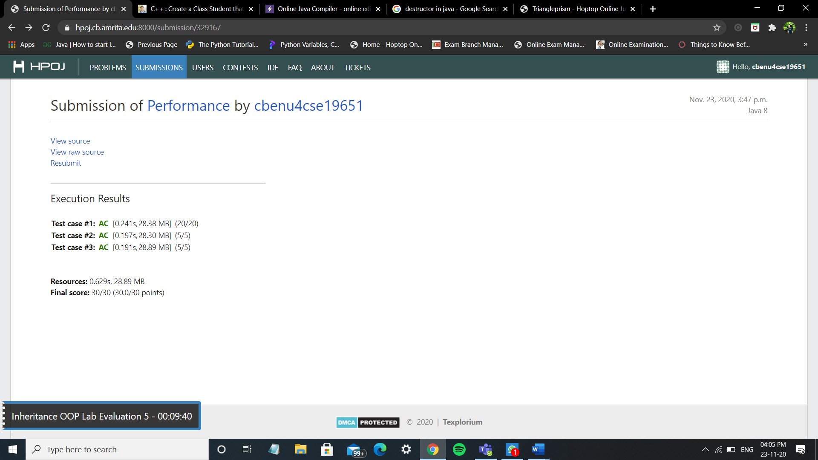

## Status:

**COMPLETED**

Write in your own words how did you implement the program related to inheritance,methods

* student class the base class from which the test class and sports class is inherited.
* Hierarchical inheritance is implemented where 2 classes are being from one class.
* There are no methods implemented in this program as it was not required according to the program question.